Urgent Care Division

Complaints Policy

UCD-GOV-002-POL

Document Control

Policy Title: | UCD-GOV-002-POL Complaints and Duty of Candour Policy Handbook Version 1
Electronic File Name (if different from above):
Final Approval by: | Divisional Quality and Safety Committee

Document Owner(s): | Role: Director of Nursing and Quality
 | Elizabeth Miller
Document Author: | Role: Deputy Director Nursing, Quality and Projects
 | Rachael Edwards
Version Number: | Version 1.0
Supersedes: | All previous Complaint Policies, SOPS, Duty of Candour Policies and templates within Vocare and Greenbrook

Amendment History:
Version Number | Date Amended | Amendment History
Draft | 24/11/2021 | Draft Sign off

Reviewers: | Job Role: Director of Nursing and Quality
 | Head of Safeguarding
 | Head of Clinical Governance
Date Reviewed: | 24/11/2021
Date signed off by Divisional Management (SMT or equivalent) | 21/11/2021
Date of Final Approval at GCGB/PAM: | 24/11/2021
Date for Next Review: | November 2023

Distribution:  Essential Reading for: | - All Urgent Care Division Staff
NB: The version of this policy posted on any Totally Subsidiary web site must be a PDF copy of the approved version.
DOCUMENT STATUS: This is a controlled document. Whilst this document may be printed, the electronic version posted on the x is the controlled copy. Any printed copies of the document are not controlled.

Contents
Document Control 2
Quick Reference Guide 4
1. Introduction 6
2. Glossary of terms 6
3. Related documents 7
4. Roles and Responsibilities 7
4.1 Managing Director – 7
4.2 Regional Directors/Head of Clinical Governance – 7
4.3 Operational /Clinical Managers – 7
4.4 Governance Team – 7
4.5 All Staff – 7
5. Main Body of the Policy 7
6. Training 8
7. Reporting Process 9
7.1 Metrics 9
7.2 Regional metrics reporting requirements: 9
8. Out of Scope 9
Appendix 1 Equality Impact Assessment Initial Screening Tool (Form A) 10
Appendix 2 What Happens Next 11

Quick Reference Guide
This QRG gives you the key points of the Policy. It is designed to help you. However, it does not replace the policy. Therefore if you are in any doubt you must refer to the policy itself.
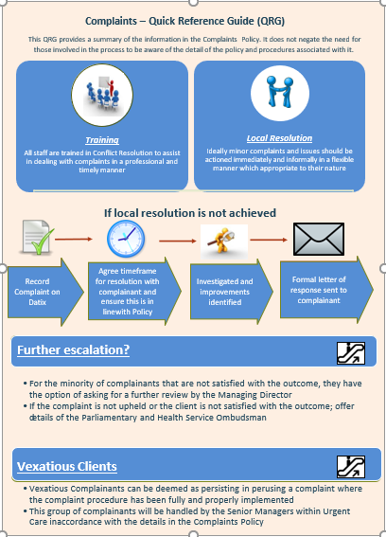

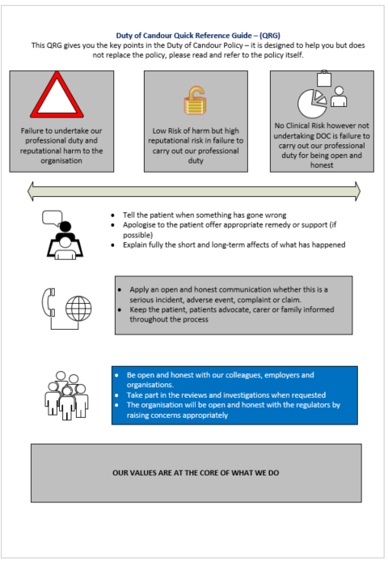

Introduction
This Policy is for the Urgent Care Division (both Vocare and Greenbrook Healthcare organisations) (part of the Totally Group).

- The Complaints Policy and Duty of Candour Policy are required as a part of the NHS Commissioning Framework for all services providing NHS Funded Healthcare and this document is aligned to the requirements laid down in the NHS England Complaints Policy, Duty of Candour Legislation and the NHS Constitution

(https://www.gov.uk/government/publications/the-nhs-constitution-for-england/how-do-i-give-feedback-or-make-a-complaint-about-an-nhs-service).
https://www.gov.uk/government/publications/nhs-screening-programmes-duty-of-candour/duty-of-candour

https://www.gov.uk/government/publications/the-nhs-constitution-for-england

- The Urgent Care Division (UCD) encourages all elements of feedback and uses this Complaints Policy (including Duty of Candour) to collate concerns and suggestions from people who use our services, to inform improvements and learn lessons. Should there be dissatisfaction with the care provided to users of the service, they have a right to be heard and for their concerns to be dealt with promptly, efficiently, and courteously.

- This policy documents how the division will handle complaints made under their obligation to manage the investigation and reporting of complaints in line with the principles identified within NHS England’s Complaints Policy (2017). This places emphasis on personal contact with the complainant so that the complaint can be fully understood, any duty of candour enacted and that the response sought by the complainant can be identified. However, any agreed resolution should be proportionate to the content of the complaint and as well as realistic and achievable.

- A complaint is an expression of dissatisfaction when expectations are not met. All complaints will be dealt with openly and transparently and will receive an evidence-based investigation. Complainants will receive support and guidance on how to complain and the division will ensure a thorough investigation takes place, with detail proportionate to the complaint made. Investigations will identify the cause of the complaint, and the division will act and implement learning as a result. Complaints are an opportunity to review the quality and performance of the service and make amends, consider lessons learnt and identify improvements to patient care and service delivery as a result.

Glossary of terms

Related documents
These documents will provide additional information to the reader:
REFERENCE NUMBER | DOCUMENT TITLE | VERSION
V-IG F611 | Vocare Verbal Complaints | 1.02
UCD 002-POL | UCD Complaints Policy | 2.02
UCD 003 -POL | UCD Duty of Candour Policy | 1.03
FORM | Verbal Compliments and Complaints | 1.01

Roles and Responsibilities

4.1 Managing Director
Holds overall accountability for Complaints within Urgent Care Division, delegated through the Director and Deputy Director of Quality and Nursing regarding adherence and maintenance of the Complaints and Duty of Candour Policy Handbook within the division.

4.2 Regional Directors/Head of Clinical Governance
Are regionally accountable for all complaints management and duty of candour within their region, including the training and development of their staff and the reporting of standards, learning and best practice.

4.3 Operational /Clinical Managers
Are responsible for listening to and capturing informal complaints, raising a DATIX, at the time the verbal complaint is made and document full details of any subsequent actions. They will attempt “local resolution” for all verbally received complaints at the time the complaint is made.

4.4 Governance Team
Managing the receipt of complaints received in writing, by email or via the website link, Vocare - Policies and statements or http://www.greenbrook.nhs.uk/how-to-complain) the Governance Team will be responsible for initial contact with complainant, acknowledging the complaint and implementing Duty of Candour, as part of managing all elements of the process, identified in the UCD Complaints and Duty of Candour Policy Handbook.

4.5 All Staff
All staff are responsible for informing the shift lead, line manager or department manager of any concern raised by users of the service. Each staff member will be advised during induction of their responsibility regarding this and of to whom they should report any concerns on to.

Main Body of the Policy
The division will treat any complaint seriously and will ensure that:
All users of the service know how to make a complaint and how the complaint will be investigated, ensuring this is thorough and fair. Posters and leaflets are available at all Centres where the division provides services.
An apology is always given, saying sorry is:
√ always the right thing to do
√ not an admission of liability
√ acknowledges that something could have gone better
√ the first step to learning from what happened and preventing it recurring
√ it is also a statutory, regulatory, and professional requirement (NHS Resolution)
- Compensations Act 2006 states; ‘An apology, an offer of treatment or other redress, shall not of itself amount to an admission of negligence or breach of statutory duty’. (source: Compensation Act 2006 – Chapter 29 page 3)
- All complainants receive information to enable them to understand the complaints procedure and feel supported throughout.
- Any ability for local resolution of verbal complaints will be sought, locally, at the time of the complaint.
- Complainants will always be treated with dignity, respect and courtesy and be given a clear plan on how the concern will be investigated.
- Any high-risk issues identified during the investigation will be dealt with at the time. This will include a full Serious Case Initial Findings process (See Urgent Care Division Incident Policy), where required, ensuring appropriate escalation and actions take place.
- All staff will be trained in complaints handling and clear guidance will be given on when, how and with whom complaints are shared.

Training

All staff dealing with complaints will be required to have achieved the following t raining, relevant to their role:
- Statutory and Mandatory Training – full compliance
- DATIX Training – For all staff involved in receiving complaints from users of the service.
- Root Cause Analysis Training – For all staff taking on the role of an Investigation Officer and any other staff deemed appropriate by the Regional Team
- Conflict Resolution Training – for all Operational Team Leaders and Clinicians
- Duty of Candour Training – For all staff dealing with complaints
- Mental Capacity Act and Deprivation of Liberties Training – For all staff dealing with patients
- Safeguarding Training – For all staff dealing with users of the services
- PREVENT Training for all staff dealing with users of the services.
- Complaints Training (division specific) for all Governance Team staff

Reporting Process

7.1 Metrics
The following metrics will be collated monthly for reporting requirements to the local Clinical Commissioning Group, Regional Quality Group and the Urgent Care Division Quality and Safety Committee. An overview of complaints by service, regional and organisation wide will also be part of the Urgent Care Division Annual Quality Account. It is expected that each Region will have a weekly/monthly reporting process to ensure focus on timeliness of complaint resolution.

7.2 Regional metrics reporting requirements:

- Local resolution achieved within 48 hours
- Number of formal complaints received (by month/by region)
- Number of complaints upheld/not upheld/partially upheld
- Acknowledgement letter standard achieved within 3 working days
- 30 working day response standard achieved (by month/by region)
- Complaints open at month end/closed within month/remained open
- Themes and trends (by month/by region)
- Redress outcomes identified (by month/by region)

Out of Scope

This policy does not cover any of the following:
- Complaints made by other NHS organisations, private or independent providers. These would be dealt with under the Health Care Professional Feedback Standard Operating Procedure. If they are made about Urgent Care Division, Urgent Care Division should raise a complaint and deal with it in line with this Policy.
- Complaints made by an Employee, about their Employment. These would be dealt with through
- Urgent Care Division’s Grievance Policy.
- A complaint that was previously investigated and concluded under this policy. This would be dealt with under the “remains dissatisfied” and referred to the PHSO
- A complaint that was dealt with through a verbal complaints process which was locally resolved at the time.
- A complaint regarding a failure to comply with the Freedom of Information Act 2000.

Appendix 1 Equality Impact Assessment Initial Screening Tool (Form A)
Document Name: |  | UCD-GOV-002-POL Complaints and Duty of Candour Policy Handbook |  |  | Date/Period of Document: |  |  | October 2021 – October 2024
Lead Reviewer: |  | Deputy Director Nursing, Quality and Projects |  |  | Other Reviewers: |  |  | Director of Nursing and Quality  Regional Clinical Directors
1 Function |  | Policy | Procedure | Strategy |  |  | Joint Document, with who?
Describe the main aim, objectives and intended outcomes of the above:
This Handbook has been developed to collate the policies and operating procedures relating to NHS Complaints management and Duty of Candor into one document. The purpose is to ensure staff who are required to manage the Complaints processes within the oprganisation have all of the inforlation they need to manage Complaints and Duty of Candour, in one place. The intention is for there to be policy led consistency in application of the requirements to fulfil the resp[nsibilities of the organisation with regards to complaints managment.
You must assess each of the 9 areas separately and consider how your document in section 1 may affect people’s human rights.
2. Assessment of possible adverse impact against any minority group
Could the document in section 1 have a significant negative impact on equality in relation to each area below? |  |  |  |  | Response |  | If yes, please state why and the evidence used in your assessment
 |  |  |  |  | Yes | No
1 | Age? |  |  |  |  | X
2 | Sex (Male and Female? |  |  |  |  | X
3 | Disability (Learning Difficulties/Physical or Sensory Disability)? |  |  |  |  | X
4 | Race or Ethnicity? |  |  |  |  | X
5 | Religion and Belief? |  |  |  |  | X
6 | Sexual Orientation (gay, lesbian or heterosexual)? |  |  |  |  | X
7 | Pregnancy and Maternity? |  |  |  |  | X
8 | Gender Reassignment (The process of transitioning from one gender to another)? |  |  |  |  | X
9 | Marriage and Civil Partnership?
You need to ask yourself:
- Will the document create any problems or barriers to any community of group? No
- Will any group be excluded because of this document? No
- Will the document have a negative impact on community relations? No
If the answer to any of these questions is yes, you must complete a full Equality Impact Assessment
3. Positive impact:
Could the document have a significant positive impact on equality by reducing inequalities that already exist?  Explain how it will meet our duty to: |  | Response |  | If yes, please state why and the evidence used in your assessment
 |  | Yes | No
1 | Promote equal opportunities | x |  | Standard documented approach to all
2 | Get rid of discrimination | x |  | Standard documented approach to all
3 | Get rid of harassment | x |  | Standard documented approach to all
4 | Promote good community relations | x |  | Standard approach to all, recognising peoples concerns and responding to them
5 | Promote positive attitudes towards disabled people | x |  | Learning from concerns and adjusting processes to meet the needs of individuals and groups
6 | Encourage participation by disabled people | x |  | Participation is sought from all complainants and their carers/families
7 | Consider more favourable treatment of disabled people | x |  | Learning lessons and implementing changes as a result of feedback
8 | Promote and protect human rights | x |  | Human Rights are considered in all responses to concerns
4. Summary
Based on the information/evidence/consideration so far, do you believe that the document will have a positive or negative adverse impact on equality?
Positive | Please rate, by circling, the level of impact |  |  |  |  |  |  |  | Negative
HIGH | MEDIUM |  | LOW | NIL |  | LOW | MEDIUM |  | HIGH
Date assessment completed:220921 |  | Is a full equality impact assessment required? |  |  | - Yes  (documentation on the intranet) |  |  | No

Appendix 2 What Happens Next
What happens when the Urgent Care Division (Vocare and Greenbrook Healthcare) receives your formal complaint?
Acknowledgement
We will acknowledge your complaint within 3 working days. Initially, a call will be made to confirm your concerns and establish what resolution you are expecting and agree the timescales (normally within 30 working days – depending on the concern). This is followed by an acknowledgement letter which will include the discussed timescale for resolving the issues and will offer you the opportunity to contact the team throughout the investigation, if required.
Timescales
The suggested timescales can be influenced by issues such as how many staff we need to speak to, how easy it is for us to access your clinical records and if other organisations are involved in your complaint. If there is a problem in keeping to the normal timescale (30 working days), we will contact you before it expires to agree an amended the timescale. We will always aim to have all complaint responses completed and returned to you in time.
The investigation
We will try to resolve your concerns in the most appropriate way. This may include:
- Talking to people who were involved in your care
- Looking at clinical records and reviewing voice recordings
- Asking expert professionals to review what happened
- Arranging a meeting with you, this gives you the chance to speak to staff directly about what has happened. You can have a friend, relative and /or an Advocate with you.
The Response
When the investigation is complete the Regional Clinical Director will send you a letter on behalf of the service. This letter will contain:
- An apology that there was cause to complain
- summary of your complaint
- how it was investigated
- what the investigation found
- any actions that are going to be taken as a result
- what to do if you are still unhappy with the answers given.
The letter will be clear and easy to understand, medical jargon will be avoided or explained. If you haven’t received this letter within the timescale agreed you may want to check when you can expect to receive it.
What if I am not happy with the response?
If you are not satisfied with the response, it is useful to look carefully through the response and see what has been answered and what you feel is still outstanding.
What are my options?
The first thing to do is to tell us that you aren’t satisfied with the response you have received.
- you can write another letter explaining what you feel is still outstanding
- you can call the person handling your complaint and discuss the response with them
- you can request a meeting to discuss your outstanding concerns
Further investigation into your complaint may be carried out, you may be invited to a meeting to discuss things and then you should receive a final written response. If we feel that everything has been done to answer your complaint, we will inform you in writing. If local resolution has been completed and you are still not satisfied with the response you can ask the Health Service Ombudsman to look at your complaint and how it was handled. This is stage two of the NHS Complaints procedure.
If you require support to make a complaint:
The NHS Complaints Advocacy Service is a free and independent service that can help you make a complaint about the National Health Service (NHS). For details of your local office please call their helpline on 0300 330 5454 or www.nhscomplaintsadvocacy.org.

